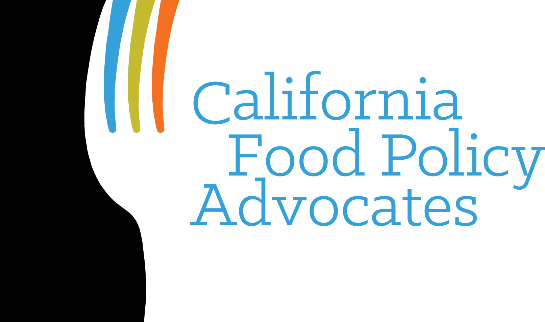

[Date]

Angela Kline, Director
Policy and Program Development
Child Nutrition Programs
Food and Nutrition Service
P.O. Box 66740
Saint Louis, MO 63166-6740

Dear Ms. Kline:

[Organization Name] thanks you for this opportunity to provide comments to respond to the ‘Food Crediting in Child Nutrition Programs: Request for Information,” 82 Fed. Reg. 58792 (December 14, 2017), and commends the United States Department of Agriculture (USDA) for taking strides towards understanding the positive and negative repercussions associated with potential changes to the crediting system.

We agree with the United States Department of Agriculture (USDA), in that it is vital to have food crediting systems and meal patterns that provide nutritious meals to a broad population of children — a particularly critical point for California, whose children have the greatest diversity of races, ethnicities, and nationalities in the country. This is best served by continuing to take a balanced approach that aims to simplify the menu planning process and provide a wide variety of nutritious food choices. These comments center on the Child and Adult Care Food Program (CACFP), and the importance of continuing to streamline program operations while making the program healthier and more welcoming for all, by expanding its range of creditable foods (particularly cultural foods) and by continuing to limit crediting of unhealthy foods.

To ensure USDA’s objectives are met, as well as the continued success of the child nutrition programs, we offer the following recommendations:

- Eliminate the Upcoming Transition to Ounce Equivalents for Grains in CACFP: USDA should not switch to a system of crediting grains, such as bread and cereal, by the ounce. The current system of crediting (e.g., a slice of bread or a cup of cereal) works well for CACFP. Moving to a system of ounce equivalents for grains will unnecessarily complicate the meal pattern, without offering any additional nutrition safeguards to the program, and jeopardize vulnerable children’s access to all the benefits of CACFP. For grains, we do not believe school meal and CACFP crediting need to be the same. (Question 1).

- Retain the Current Yogurt Crediting Amounts: Establishing a two (2) tiered crediting system for yogurt based on protein content would be complex and confusing while at the same time decreasing the overall nutrient value of the food-based meal pattern. (Questions 15, 16, 17a).

- Preserve the Food-Based Crediting System. Maintain USDA’s current food-based crediting system which allows providers to create a nutritious menu based on a meal pattern without needing to calculate nutrients. The current food-based crediting system already takes into account the full range of nutrients for each food group in the meal pattern. There is no need to start adding imitation foods or to consider fortification in the crediting of foods. (Question 4).

- Examine Options for Crediting Foods Without Child Nutrition Labels. USDA should examine options for crediting foods including when a Child Nutrition label or manufacturer’s statement is not available. (Questions 5, 8).

- Consider Customary Use and Expand Range of Creditable Cultural Foods: Address issues around including cultural foods such as Tempeh. We recommend adding more cultural foods to the Food Buying Guide to add clarity on whether or not they are creditable. We agree with USDA current practice of considering the customary use of a product (e.g., tortillas and tortilla products should continue to be creditable because they are used in the preparation of meals). When considering customary use it is essential to take into account a wide variety of cultures and diets because the Child Nutrition Programs serve such a diverse population. (Questions 6, 9, 22, 23).

- Continue to Exclude Food of Limited Nutrition Value: Foods of limited nutrition value, such as bacon, summer sausage and ice cream, should continue to be excluded from crediting. Program operators should not be able to count any of the foods listed in Section 5 of the food buying guide toward meeting a category in the meal pattern (Question 21).

Food crediting is critical not only for establishing nutrition standards, but also for establishing cultural standards. Thank you for your commitment to prioritizing equitable access to nutritious foods through food crediting, and for your continued efforts to make child nutrition programs operationally streamlined and welcoming of all providers and children. We deeply appreciate your consideration of these comments.

Sincerely,
[Your Name]
[Your Organization’s Name]

