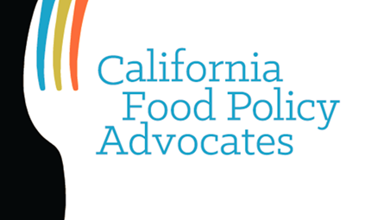
Simplified CalFresh for Senior and Disabled Households

  - Applying for CalFresh is easy!

If you live in a household where everyone is age 60+ and/or disabled with no earned income, it is now easier than ever to get help paying for healthy food with CalFresh.

- There is a new simpler application process and less paperwork for senior and disabled households.
- Once approved for CalFresh, you can be certified to receive benefits for three years.
- You will only need to fill out an easy “CalFresh Benefits Check-up” form once a year.
- When it is time to renew your case after three years, you will only need to make sure your information is current.

  - If you are already receiving CalFresh

- Your caseworker will switch you over to this simpler process at your next recertification.
- Reporting will only be once a year, which means less paperwork for you to fill out.
- Once switched over, your household will not have to be interviewed again.
- When it is time to renew your case after three years, you will only need to make sure your information is current.

  - How can I find out more?

You can learn more about CalFresh for senior and disabled households at CFPA’s website. Visit www.cfpa.net/calfresh for more information.

